**Carers Services - 6 Monthly Review Report**

Please complete PARTS 1, 2,3 and 4 as fully as possible, sign, date and return to

[Beverley-stevens@sandwell.gov.uk](mailto:Beverley-stevens@sandwell.gov.uk). By end October please.

**Part 1 – Service Overview**

|  |  |
| --- | --- |
| Name of Service the grant is for: | African Caribbean & BME Carers Information/Advice and Navigation Service |
| Start Date of Funding for Service: | 01/04/2020 – 30/09/2020 |
| Service Manager and Telephone Number | Deska Howe (0121 525 9177) |
| Commissioner and telephone number | Beverley Stevens  0121 569 5406 |
| Monitoring Period (6 months) | 01/04/2020 – 30/09/2020 |
| Amount of Grant for 6-month period | £5,000.00 |

**Summary of 6 months’ outputs and outcomes (2-3 lines):**

This study considers the impact of COVID19 on African Caribbean/Caribbean/Dual Heritage carers that live and work in Sandwell, emerging evidence locally has identified that our community are disproportionately affected by the virus and we are 4.2 times more likely to end up on critical/intensive care wards or die compared to the white British populations. In addition, evidence shows that the fatalities cuts across various socioeconomic backgrounds which includes hospital consultants, nurses and healthcare workers it is not just economic disadvantaged families and carers with our communities that are affected by the pandemic, and Sandwell Public Health and Public Health England have ‘categorically stated that there is a clear association between the virus/ economic disadvantage, wider determinates of health and pre-existing health inequalities that have been exacerbated by the virus and pandemic’.

In this period, we referred 25 carers to Sandwell Enquiry for a Carers Assessment/Carers Direct payment. So far 17 people have received a Carers one off Grant payment of £400.00 each and 3 carers have received £120.00 and 5 carers are still waiting for the outcome of the assessments.

**National & Regional Data**

***Experiences of African Caribbean and minority ethnic carers are different and more challenging***

Set against what we know about carers in general, evidence in Sandwell and across our black country area has constantly shown that the experiences of black and minority ethnic carers are frequently different and may be more challenging that those of their white counterparts. For example, black and minority carers are more likely to be struggling financially and are more likely than majority white carers to care for 20 or more hours a week (56% compared to 47% (NHS Information Centre). These greater hours of caring may increase black and minority ethnic carers risk of poor health, difficulties in keeping paid employment and social exclusion. The experiences of African Caribbean and Dual Heritage carers are frequently different and may be more challenging that those of white carers. Our research has identified that in Sandwell they are not only less likely to access services but may also find services less satisfactory than white carers.

***Black and minority ethnic carers access services less frequently and find them less satisfactory***

Despite their additional challenges, evidence suggest that compared to their white equivalents, black and minority ethnic carers are even less likely to access and engage with formal services (Dunlop et al. 2002), even though they report greater need for support (Giunta et al., 2004: Scharlach et al., 2006). There remain concerns that there are misconceptions amongst service providers about the availability of support from extended families (Afiya Trust 2008) but other possible barriers to accessing and engaging with services may include cultural expectations, stereotypes and language barriers (Greenwood et al., 2015) There is also some research suggesting that black and minority ethnic carers are more likely to find services incentive to their needs. Black and minority ethnic carers are more likely to say they were unlikely to use services, not only because they were unaware of them but also because they found them too expensive or inflexible (Yeandle et al, 2007) Furthermore, some surveys have found that minority groups rate services as less satisfactory than white carers (Thomas et al, 2009; Health and Social Care information centre 2013) but clear explanations for this have yet to be identified. (Greenwood et al 2007).  In addition, evidence from Carers UK also shows that black and minority ethnic carers are not only less likely to be in receipt of practical and financial support but also are more likely to wait longer to access it. Explanations for this delay are similar to those for fail to access services altogether – lack of information provided in culturally appropriate ways, language and literacy barriers and poor knowledge of services and entitlements (Carers UK 2015). Providing culturally sensitive services can also be challenging for social care staff. This is not only because of insufficient cultural knowledge but also because staff often struggle to involve minority groups in developing and providing services (Manthorpe et al 2012) The involvement of these users would be expected to help develop more sensitive accessible services.

***The impact of personalisation and the Care Act on black and minority ethnic carers***

Personalisation is a broad term but refers to trying to offer services that fit with individual user needs. It may be especially helpful to carers giving them greater control in how they manage their caring role (Carr 2011) We know carers from black and minority ethnic groups often have differing needs and experiences to other carers making personalisation potentially very important when supporting them. Ways of achieving personalisation vary but include e.g., personal budgets and direct payments.

We are aware that Sandwell MBC and the Combined West Midlands Authority have agreed to be part of a national inquiry so they can try to understand why such a high number of African Caribbean people from African Caribbean & BAME backgrounds are dying from the virus in the 1st wave of Covid 19 infections. The review, to be led by NHS England and NHS Improvement and Public Health England, is welcome.

**Health Secretary Matt Hancock has said that people from ethnic minority**

**backgrounds are "disproportionately" dying with coronavirus.**

A number of reviews, including by the Office for National Statistics and Public Health England, have now concluded that this is the case. Suggested reasons have included existing health inequalities, housing conditions, public-facing occupations and structural racism.

There were at least 3,876 deaths of black and minority ethnic (BAME) individuals in hospitals in England up to 9 June 2020. This means that, where ethnicity is known, BAME people represented 15.5% of all deaths to this point. The 2011 census - the most accurate source - [showed that 14.5% of the English population](https://www.ethnicity-facts-figures.service.gov.uk/uk-population-by-ethnicity/national-and-regional-populations/population-of-england-and-wales/latest) were from BAME backgrounds. But clearly the proportion may have grown since then.

* [Virus 'has disproportionate impact on BAME groups'](https://www.bbc.co.uk/news/uk-england-oxfordshire-52292569)
* [Coronavirus cases to be tracked by ethnicity](https://www.bbc.co.uk/news/health-52338101)

In 2016, [the Office for National Statistics estimated](https://www.ons.gov.uk/peoplepopulationandcommunity/populationandmigration/populationestimates/methodologies/researchreportonpopulationestimatesbycharacteristics) that it could have increased to 15.4% of the population.

Similar breakdowns by ethnicity for Wales, Scotland and Northern Ireland are not currently available.

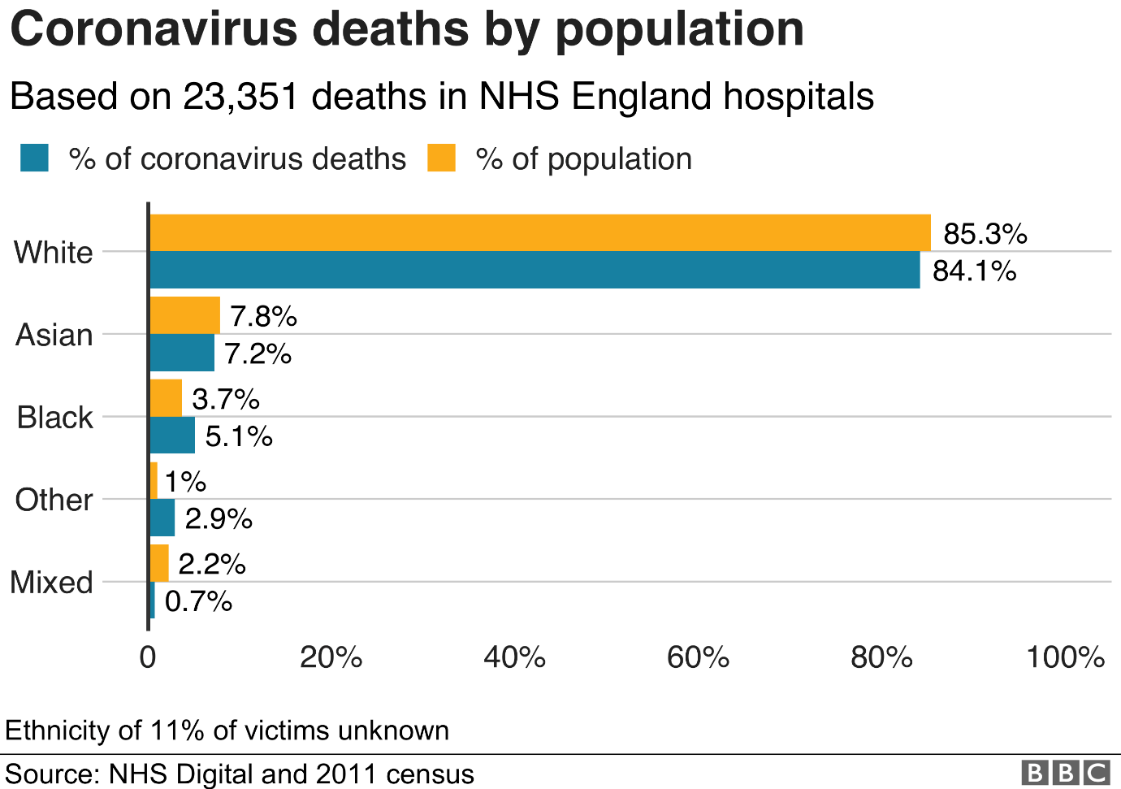

These numbers do not show a great disproportionality in BAME deaths, but once we account for demographics - such as age and location - a different story is told. Research [from the Institute for Fiscal Studies (IFS)](https://www.ifs.org.uk/inequality/chapter/are-some-ethnic-groups-more-vulnerable-to-covid-19-than-others/) shows that if we only looked at where BAME communities were concentrated, we might expect to see higher death rates than that for white British individuals [Black African Brits face 'triple' virus death rate](https://www.bbc.co.uk/news/uk-52492662).

In 2016, [the Office for National Statistics estimated](https://www.ons.gov.uk/peoplepopulationandcommunity/populationandmigration/populationestimates/methodologies/researchreportonpopulationestimatesbycharacteristics) that it could have increased to 15.4% of the population.

Similar breakdowns by ethnicity for Wales, Scotland and Northern Ireland are not currently available.



These numbers do not show a great disproportionality in BAME deaths, but once we account for demographics - such as age and location - a different story is told. But even when you adjust for where the coronavirus outbreak has hit hardest, the Office for National Statistics, the Institute for Fiscal Studies think-tank and Public Health England all conclude that people from ethnic minorities are being disproportionately impacted.

Research [from the Institute for Fiscal Studies (IFS)](https://www.ifs.org.uk/inequality/chapter/are-some-ethnic-groups-more-vulnerable-to-covid-19-than-others/) shows that if we only looked at where BAME communities were concentrated, we might expect to see higher death rates than that for white British individuals. [Black African Brits face 'triple' virus death rate](https://www.bbc.co.uk/news/uk-52492662) however, the research says that this geographical factor is counter-balanced by the factor of age. Most minority groups are much younger on average than white Britons - and therefore should be less susceptible to the virus. The IFS concludes that, if we look at both geography and age combined, the death rate should be lower for most ethnicities than for white people.

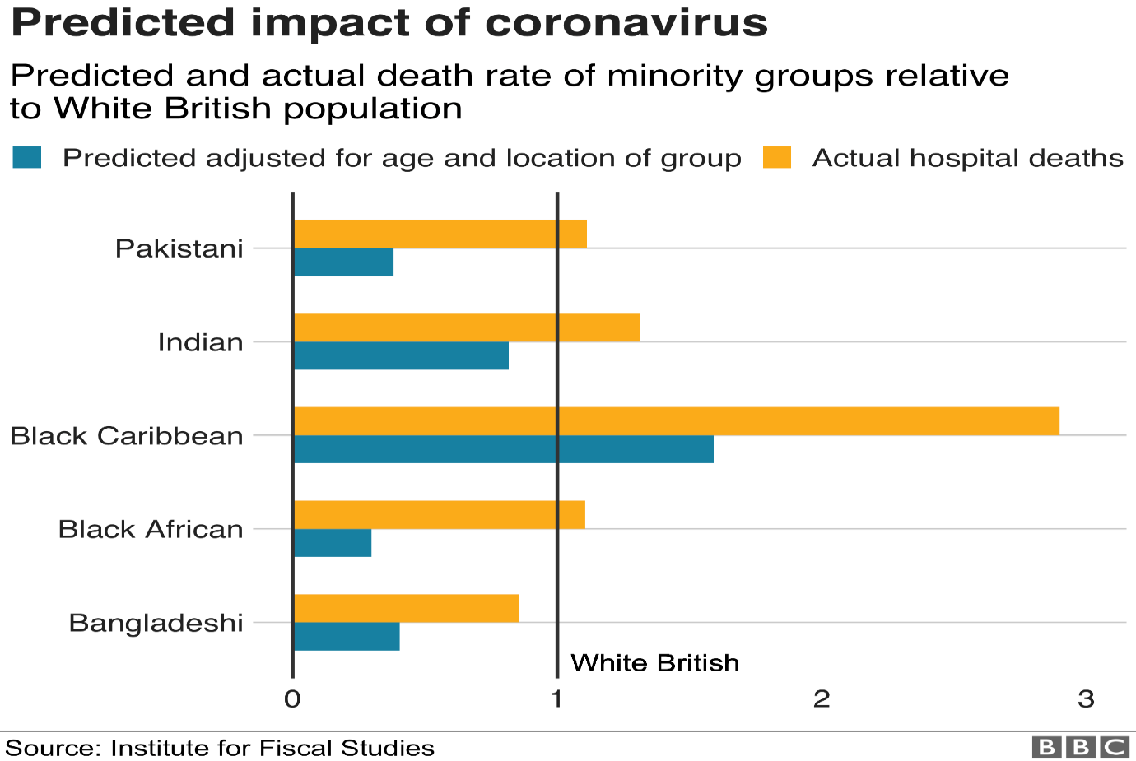

It estimates that the deaths of black Africans are 3.7 times higher than might be expected by geography and age, 2.9 times higher for Pakistanis and 1.8 for black Caribbean people (who are older on average than other minority groups). Public Health England, [which approached the issue in a similar way](https://assets.publishing.service.gov.uk/government/uploads/system/uploads/attachment_data/file/889195/disparities_review.pdf) by adjusting for age, found similar disparities in both the infection rate and deaths for BAME people. The [ONS research goes one step further](https://www.ons.gov.uk/peoplepopulationandcommunity/birthsdeathsandmarriages/deaths/articles/coronavirusrelateddeathsbyethnicgroupenglandandwales/2march2020to10april2020) than these reviews and looks at other factors, such as health and deprivation.

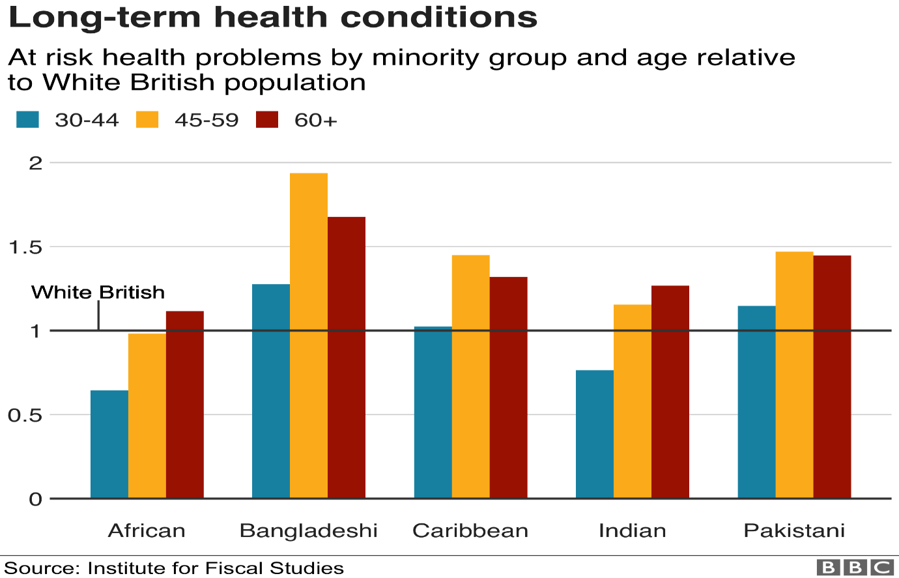

**COVID 19 - Local Context: Population Health Management**

Sandwell Public Health have stated there is also a clear association and correlation between existing underlying health conditions, inequalities in health and deprivation which increases the likelihood of people catching and dying from the virus, this research aim to identify how Covid 19 has impacted of African Caribbean Carers that we support through our project.

The 2011 Census showed that there were just 600,000 black and minority ethnic carers in England and Wales and as with carers in general, this group is steadily increasing in number. Over the life span of our project, year on year we have identified carers not known to public sector organisations and we have demonstrated that African Caribbean and Carers have differing needs and experiences to white British carers making personalisation potentially very important when supporting them. Without our service and support, the carers we have supported would not have access support services for themselves and if we had not referred them to Sandwell Enquiry for a Carers assessment, they would not have received a Carer Direct Payment as they were not known to Public sector bodies and if they were, they were not offered any support.

There is also a clear association and correlation between the corona virus, pre-existing underlying health conditions, inequalities in health and deprivation which increases the likelihood of people catching and dying in the pandemic and if nothing changes even more African Caribbean/Caribbean/Dual Heritage people will die in the 2nd waive.

**Sandwell Trends/Sandwell Census 2011**

Duel Heritage communities were more like to be unemployed compare to other ethnic communities, the 2nd highest unemployed group were African Caribbean communities which means 3rd generational families and carers are more deprived now compared to their parents and grandparents.

**Sandwell Public Health Population Data: COVID 19 Positive Cases**

**in Sandwell – March and September 2020**

Sandwell estimated that there are between 35,000 to 36,000 carers in Sandwell with approximately 3000 accessing services however this is not been broken down by protective characteristic such as ethnic group/age/gender, in addition the data is not broken down across Sandwell Towns and Neighbourhoods.

The tables below show the numbers of people living in Sandwell who have tested positive for COVID19 by age, gender, and Sandwell town.  We have kept the ethnic groups quite broad, Black/ African/ Caribbean, Mixed Ethnicity, Asian, and other ethnic group and white British.  In the ‘Other Ethnic, ‘Chinese’, ‘other ethnic groups’ and all other white categories, other than White British. In addition, ethnicity data from the 2011 Census, this is quite dated now but is the best Sandwell Public Health have concerning ethnicity until the new Census data is compiled in 2021. Sandwell’s estimated population in 2018 was 327,378, by 2030 Sandwell Public Health estimate that the population will increase by 30,300 people (Sandwell Trends August 2019).

|  |  |  |  |  |  |  |  |
| --- | --- | --- | --- | --- | --- | --- | --- |
| ***COVID19 Sandwell Public Health Data: Positive Cases by Ethnic Groups*** | | | |  |  |  |  |
| COVID -19 Positive Cases from 11th March 2020 to 16th August 2020 | | | | | | | |
| Age Group | Ethnic Group | | | | | | Grand Total |
| Asian | Black/African/Caribbean | Mixed Ethnic Group | Other Ethnic Group | White British | Unknown |
| 0-19 | 65 | 9 | 6 | 14 | 13 | 11 | 118 |
| 20-54 | 341 | 101 | 19 | 85 | 282 | 127 | 955 |
| 55 plus | 148 | 70 | 8 | 103 | 609 | 46 | 984 |
| Grand Total | 554 | 180 | 33 | 202 | 904 | 184 | 2057 |
| Note: For more recent dates, numbers might change as back dated data are received | | | | | | | |
| COVID-19 Positive Cases from 11th March 2020 to 16th August 2020 | | | | | | | |
| Gender | Ethnic Group | | | | | | Grand Total |
| Asian | Black/African/Caribbean | Mixed Ethnic Group | Other Ethnic Group | White British | Unknown |
| Female | 280 | 111 | 19 | 109 | 497 | 75 | 1091 |
| Male | 274 | 69 | 14 | 93 | 407 | 107 | 964 |
| Unknown |  |  |  |  |  | 2 | 2 |
| Grand Total | 554 | 180 | 33 | 202 | 904 | 184 | 2057 |
| Note: For more recent dates, numbers might change as back dated data are received | | | | | | | |
|  |  |  |  |  |  |  |  |
| COVID -19 Positive Cases from 11th March 2020 to 16th August 2020 | | | | | | |  |
| Sandwell Town | Ethnic Group | | | | | |  |
| Asian | Black/African/Caribbean | Mixed Ethnic Group | Other Ethnic Group | White British | Unknown |  |
| Oldbury | 77 | 35 | 6 | 18 | 109 | 34 |  |
| Rowley Regis | 30 | 31 | <5 | 17 | 170 | 17 |  |
| Smethwick | 207 | 45 | 13 | 38 | 95 | 49 |  |
| Tipton | 34 | 12 | <5 | 34 | 123 | 17 |  |
| Wednesbury | 37 | 15 | <5 | 36 | 171 | 21 |  |
| West Bromwich | 169 | 42 | 5 | 59 | 236 | 46 |  |
| Grand Total | 554 | 180 | 33 | 202 | 904 | 184 |  |
| Note: For more recent dates, numbers might change as back dated data are received | | | | | | |  |

Below is the latest data for new Covid-19 cases reported up to the 21st Sept 2020

|  |  |  |  |  |  |  |  |
| --- | --- | --- | --- | --- | --- | --- | --- |
| COVID -19 Positive Cases from 11th March to 21st September 2020 | | | | | | | |
| Age Group | Ethnic Group | | | | | | Grand Total |
| Asian | Black/African/Caribbean | Mixed Ethnic Group | Other Ethnic Group | White British | Unknown |
| 0-19 | 154 | 22 | 11 | 23 | 34 | 25 | 261 |
| 20-54 | 547 | 142 | 32 | 108 | 385 | 180 | 1394 |
| 55 plus | 189 | 82 | 8 | 117 | 654 | 58 | 1,108 |
| Grand Total | 882 | 246 | 51 | 248 | 1,073 | 263 | 2,763 |
| Note: For more recent dates, numbers might change as back dated data are received | | | | | | | |
|  |  |  |  |  |  |  |  |
| COVID -19 Positive Cases from 11th March 2020 to 21st September 2020 | | | | | | | |
| Gender | Ethnic Group | | | | | | Grand Total |
| Asian | Black/African/Caribbean | Mixed Ethnic Group | Other Ethnic Group | White British | Unknown |
| Female | 446 | 146 | 30 | 135 | 592 | 102 | 1,451 |
| Male | 436 | 100 | 21 | 113 | 481 | 158 | 1,309 |
| Unknown |  |  |  |  |  | 3 | 3 |
| Grand Total | 882 | 246 | 51 | 248 | 1,073 | 263 | 2763 |
| Note: For more recent dates, numbers might change as back dated data are received | | | | | | | |
|  |  |  |  |  |  |  |  |
| COVID -19 Positive Cases from 11th March 2020 to 21st September 2020 | | | | | | |  |
| Sandwell Town | Ethnic Group | | | | | |  |
| Asian | Black/African/Caribbean | Mixed Ethnic Group | Other Ethnic Group | White British | Unknown |  |
| Oldbury | 116 | 47 | 10 | 26 | 136 | 45 |  |
| Rowley Regis | 49 | 31 | <5 | 18 | 191 | 23 |  |
| Smethwick | 322 | 68 | 19 | 44 | 109 | 78 |  |
| Tipton | 70 | 17 | <5 | 39 | 153 | 21 |  |
| Wednesbury | 49 | 20 | <5 | 45 | 205 | 26 |  |
| West Bromwich | 276 | 63 | 10 | 76 | 279 | 70 |  |
| Grand Total | 882 | 246 | 51 | 248 | 1,073 | 263 |  |
| Note: For more recent dates, numbers might change as back dated data are received | | | | | | |  |

Public Health England (PHE) have confirmed they do not hold Sandwell Populated data on COVID 19 deaths in Sandwell so a comparison comparing infection rates to death rate inn Sandwell has yet to take place, a request has been made to Sandwell & West Birmingham CCG see if the combined data can be extracted from

* Primary Care Networks GP Practices data stored System One which is analysed by CSU
* Sandwell patients and staff have died at the Queen Elizabeth (QE) Hospital, Sandwell & West Birmingham, Manor and Russell’s’ Hall Hospital sites
* West Bromwich Register Office (Births and Deaths)

**Methodology**

This study is not an academic study, the research has been carried out on behalf of Adult Social Care Health & Well Being Carers Commissioning Manager who manages and oversee’s funded carers support services in Sandwell under the umbrella of the Better Care programmes which is funded jointly by Sandwell & West Birmingham CCG and she reports to the Joint Partnership and Sandwell Health & Well Being Boards.

All the carers either have been supported by the West Bromwich African Caribbean Resource Centre’s (WBACRC) Day Care or African Caribbean Carers Information/Advice and Navigation Services. Most of the participants did not have access to digital platforms at home, those that did stated they would disengage if we used virtual meetings, webinars or video platforms like WhatsApp so we decided to obtain the information through telephone interviews.

We ask our carers to consider 6 key question, which were agreed by Sandwell Adult Social Care Health & Well Being ‘Carers Commissioning Manager’ and you will see their responses we decided to carryout telephone interviews, we ask 6 key questions to identify how the pandemic has impact of the caring roles and family life and the responses to our questions are below.

**Demography**

Most of our carers lived in Sandwell, but not always in the same Sandwell, we have categorised some carers as ‘other’ which means the family carers lives outside of Sandwell be their family members who they care for live in Sandwell.

**Key Finding**

We are aware that in comparison to other research that has taken place in Sandwell the total sample study is small however if you compare larger studies against our study the inclusion and participation rate of African Caribbean and Duel Heritage engaging in our study is much higher small sample however compared to other larger studies that have taken place in terms of participation and inclusion the number are extremely high and it gives readers a snapshot of the needs and lived experiences of the individuals who took part.

In total 60 people participated in our study, in terms of the selection process we targeted existing carers who use our services across our African Caribbean and Health and Well Being Day Care Services, and we have used personal quotes which gives a wider insight into their daily lives and challenges.

1. How has COVID 19 Corona Virus Impacted on your life and families lives

All our participants stated that COVID 19 had impacted on their live and family life in some shape or form

5% stated they were suffering from food poverty, and they had to be sign posted to a local food bank

25% stated they felt lonely and isolated even when they live in a multi-generational household

95% stated that the family members physical and mental health had deteriorated because they have not been able to attend the West Bromwich African Caribbean Resource Centre (WBACRC) Day Care Service

70% stated they felt anxious and depressed because they could not see visit their family

35 % stated their relationships with their partners and children, this was partly due people spending a lot of time together in closed spaces and due to family members or friends/neighbours dying and not being able to attend the funerals to say goodbye and grieve.

36% said that they had developed their own health conditions as a result of their caring responsibilities.

45% said that their sleep had been impacted by their caring responsibilities

21 % said that they had suffered loss of appetite due to their caring responsibilities

27% of the survey respondents said that their mood had been affected by their caring duties and that they could be short tempered or irritable as a result

45% said that they had needed to see their own GP in the last 12 months due to their caring responsibilities.

**‘’ Quote”**

*’N’ stated: It has been very stressful, i works as a Support Worker and i am around lots of people with underlying health conditions therefore i am been unable to see my mom, family or friends but i has kept communication going by phone. ’N’ also said she has felt extremely tired with work, worries over her mother and the stress of COVID 19. ’Ns’ mother’s dementia and her physical and mental health deteriorating faster due to the pandemic and to increased isolation and loneliness. ’N’ is also worried that one day her mom might leave the cooker on and would like assistance with a self-turn off cooker, WBACRC referred ’N’ and her mom to Sandwell Enquiry for assessment to see if we both could receive support from a Social Worker.*

**‘’ Quote”**

*’DH’ stated: COVID 19 has affected me enormously, being a full time university student i am unable to access the university campus to study, food shopping has been a strain due to the long queues and waiting times plus i also has to shop for my father who lives in an extra care scheme. ’DH’ stated my new routine is the same routine everyday which can be very frustrating because I am a very active person who likes to do differently so I have variety in my life.*

**‘’ Quote”**

*’J’ stated: i am coping with my increased role as a carer due to COVID 19, but it has impacted hard on my father and he is frightened to go outside and is also frighten for my sister who will be returning to work soon.*

1. Are you still able to go to work, have you had to reduce hours, or have you been furloughed?

10% said they had lost their jobs due to the pandemic

15% said they had their hours reduced

33% said they were over 65 years of age and they were retired

10% said they were working could from home

32% said they were still working, in some instances their working hours had increased due to their colleagues either shielding or being off work sick

***‘’ Quote”***

*’C’ stated: I look after my husband as well as working full time and the pandemic as made my life more stressful. Without their support I received from the WBACRC I would not be managing, I have reduced my hours at work due to my husband shielding. In my work role we now have increased numbers of students and staff returning to premises, I was advised by the GP to reduce my hours and shield with my husband. I have felt extremely tired as each day and night have been the same. The staff at the WBACRC have accessed arrange of support services for me including Aids and Adaptations for my husband and through their referral for a Carers Assessment I received a one off £400.00 payment who came in handy as our weekly income has reduced.*

***‘’ Quote”***

’AM’ stated: COVID 19 as impacted on my life in a number of ways, my husband is no longer able to socialise with others as he is deemed as high risk, so he has to shield, ’AMs’ is his wife’s main carer, ’N’ does not usually get free time for himself, has his committed to caring for her. Before quarantine ’AM’ was using a sitting service twice a week for a few hours but due to quarantine ‘N’ is not able to take get a break from his caring role. ’N’ had was referred by the WBACRC provided a sitting service for an hour twice a week, he was also referred to Sandwell Enquiries Practical Support Team for additional support

1. How are you balancing your work, with your caring role and home schooling?

65% of participants stated they were struggling to balance their work and their caring role

35% of participants who supported their children with home schooled found this difficult

***‘’ Quote”***

*’S’ stated: COVID 19 has affected me immensely, especially when it comes to the restrictions that have been put in place which has not allowed me to see my family and friends. It is not normal for human beings to stay caged indoors at home and on top of that I have to school my children for the last four months has affected my emotionally/mentally and physically. I feel exhausted and my energy levels are low for most days, I appreciate all the support I received from WBACRC, particularly with them shopping for my elderly mother and providing a social distancing sitting service to breakdown her isolation and loneliness. She really misses spending time at their Health & Well Being Day Care Service, she misses the staff and the friends she has made there which has impacted on her physical and mental wellbeing. I also look forward to their befriending calls, I know they have limited capacity, put I would rather stay with a service I know and trust than talk to complete strangers.*

***‘’ Quote”***

’DH’ stated: COVID 19 has affected me in so many ways, I am a full time university student however I am unable to access the university campus to study, food shopping has been a strain due to the long queues and waiting times plus I have had to do the food shopping for my father who lives in an extra care scheme. My new routine is the same routine everyday which can be very frustrating as I am a very active person who likes to vary my day, but this was not possible until I gained support from the WBACRC. They phone me twice a week (befriending calls) to see if I am okay and they do safe and well check. My dad attended their Health & Well Being Day care service twice a week, he misses his friends, and he misses playing dominoes. The staff now do his shopping which gives me more time to study and I can spend virtual time with my friends. Commissioner of Carers & Day Care services need to understand that our community need ‘culturally appropriate services and the services we have need extra investment not just to cover the actual costs put also to increase the capacity in their services and workforce so that they can help more vulnerable carers and cared for people.

1. Are you more tired?

25% of the participates stated because they were not able to use the gym or go swimming, they had gained weight, so they had become less active

35% of the participates stated they had made less healthy choices during the lockdown, orders of takeaways had increase and there had also been a slight increase in their alcohol intake

40% of participants stated there has been no change

***‘’ Quote”***

*’AM’ stated: My working hours have increased from 40 hours to 50+ hours which has made my life more difficult particular as i feel I am putting myself and my family at risk but being a key worker, I am a single parent so it is essential that I attend my job. My energy levels are low, I constantly feels tired and I have noticed each week that my self-esteem is getting lower. At one point I lost her voice due to feeling rundown, the WBACRC SAPPHIRE and Carers information/Advice and Navigation services have been a lifeline to me, the staff do my parents shopping each shopping for my parents, they have sorted out their benefits and arranged for handrails and a raised toilet (aids and adaptations) to be fitted in their home and as a carer they referred me to Sandwell Enquiry for a Carers Assessment, and I received a one off payment totalling £400.00. When lock down ends, I hope my parents will also be able to attend their Health & Well Being Day Care Service, which will re-connect them with their community and hopefully they will either make new friends or reconnect with old acquaintances. Receiving this support has taken a lot of pressure of me, I am able to focus on myself and my children know that my parents are well supported by the SAPHIRE Team.*

1. Have you had to self-Isolate?

25% said they have had to self-isolate, they felt disconnected, socially excluded from their family, friends and the wider community.

30% said they had to shield

45% continued to work

***‘’ Quote”***

*’C’ stated that COVID 19 as affected her extremely badly, I am 73 years of age with long term health condition which means I have had to self-isolate and shield and as a consequence i have not been able to see or visit my frail elderly mother who is 93 years of age. I feel more tired and I am eating more than usual due to the fact my daily routine has been restricted, my brother has taken over the responsibility for caring for our mother’s and the WBACRC staff have been doing befriending social distancing visits and care navigation for their her so our mom can remain living independently at home, as a family we all appreciate the support we are receiving as it is a lifeline to their mom and the wider family and my mother can not wait to star attending their Day Care service and see her friends.*

***‘’ Quote”***

*’M’ stated: The virus has impacted on me and my family life greatly, my stress levels are high plus and I get even more stressed when central government change their COVID 19 daily advice which frustrates and confuses me as I need clear and consistent information but the advice the public are given is inconsistent and hard to follow. My family life is uprooted now because i not able to visit my mother and neither were the wider family or grand/great grandchildren. I currently work in a nursing home, recently my children and i have had to self-isolate from the rest of the family as one of the residents tested positive for COVID 19, staff at the WBACRC collected our shopping and prescriptions and left it out our front doors and this service has been a lifeline to us.*

***‘’ Quote”***

*‘A’ stated: COVID 19 as affected her daily routine and i now work from home. My mother is very frail and i am mindful who she associates with. Not seeing her children and grandchildren is very stressful for her, I wear PPE when delivering my mother’s shopping and not being able to enter her house is emotionally draining. My mother was also discharged from recently, we both receive telephone befriending and safe and well checks from the WBACRC’s SAPPHIRE Service, we have both been shown how to use WhatsApp on our phones so we can talk to each other virtually and my mother speaks to all her family members she can see then on her phone.*

1. What services/support do you need now and in the future for example (befriending/respite service, telephone support service?

60% of the participants stated they would benefit from culturally sensitive home respite and sitting service, they did not want random strangers in their homes or parent’s homes, they wanted people who they had an existing relationship as they were very wary of strangers

30% of the participants stated they would benefit from a telephone befriending service

10% stated they would ask for the above support when they needed help

***‘’ Quote”***

*‘F’ stated: I used to care for my mother for 10 years however she has recently died from the COVID 19 virus, I have tried to deal with my mother’s death by occupying my mind and time by going for long walks and talking to my family virtually but i will never cope with the loss of his mother. I do not want to be referred to a bereavement or counselling service, i appreciated all the emotional and practical support i received from the WBACRC staff and I would like to keep in touch via your telephone befriending service as your staff have been my rock through this difficult time in my life.*

***‘’ Quote”***

‘M’ stated: COVID 19 has changed my world, I am more isolated than ever as I am a full time Carer for my husband plus, I am now working from home. My husband is disabled, and he is in a wheelchair. His isolation has also increased, and he is no longer able to attend WBACRC Health & Well Being Day Care Service however the staff now do regular befriending calls for me and my husband and the Day Care staff to visit my husband at home (social distancing with PPE), and they play dominoes.

**Age of participants**

In terms of age, the highest aged range was between 45-54 years at 42% of the respondents, those aged 65 years of age and over had the 2nd highest percentage (33%) and finally those aged between 35-44 years were the third highest group (25%).

The 2011 Census does not provide the same age bands for a direct comparison but the working age population between 16 and 60 in the Census data is 58.3% of the population. Therefore, the percentage of working age respondents to the survey was only slightly higher than the 65 years and over general population.

**Gender**

In terms of the gender breakdown 85 percent of the participates who female and 15% were male.

**Ethnicity**

In terms of ethnic grouping all the participant were either from a Caribbean and dual heritage background (30 Jamaican, 3 Barbados, 6 Nevis, 2 Antigua, 3 The Bahamas, 2 Martinique, 2 St Vincent & Grenadines, 3 Trinidad and 1 Tobago, 1 Saint Lucia, 7 Dual Heritage (Jamaican & White British) in the Caribbean.

**Conclusion**

Over the years there has been a lot of rhetoric from commissioners around addressing the disparities in health and health inequalities and promises to commissioning services around the need’s local citizens/patients and carers but when it comes to investing in targeted prevention services often delivered in partnership with VCS providers investment in this area minimal or non-existent.  There is a lot of anger within the African Caribbean and Dual Heritage communities, they are looking for real and measurable/meaningful changes in the way that services are commissioned and delivered to seldom heard established groups now and in the future.

This report shines a small spotlight on the lived experiences of African Caribbean Carers who have struggled to provide support to their disabled, frail, and ageing family members that live in Sandwell during the pandemic. Our findings also attempted to link local/regional/national studies that have previously highlight the different needs of African Caribbean/Caribbean/Dual Heritage carers are ‘fundamentally different’ compared to white British carers and other ethnic group. Health inequality for our carers and our wider community living in Sandwell is not a new phenomenon, inequalities have existed for decades ‘pre - Windrush’ however recent event in the media ‘**Black Lives Matter**’ has also highlight social injustice, institutional/structural/organisational ‘unconscious and conscious’ bias. We have to systematically tackled, dismantled these structures otherwise our leaders, decision makers/influencers and commissioners with have learned nothing from the pandemic and through their actions and inaction this will perpetuation the cycle of inequality and nothing will have been learned from the pandemic.

Using local data to develop an inclusive population management system to shape that shape co-production with African Caribbean groups and local citizen is essential when developing integrated joint deliverable services that are target and compliment universal services in Sandwell 2030 Vision/COVID 19 Sandwell’s Reimaging Place Based Plan.

**Recommendations**

Based on the above context, this report makes the following recommendations which are based on national, regional and local data and evidence we have submitted in previous report to SMBC Adult Social Care Health & Well Being.

1. Sandwell’s Health & Well Being Board (SHWB) board have agreed to review the Joint Carers Strategy due to the impact the pandemic has had on African Caribbean, BAME communities and vulnerable groups, the Equality Impact Assessment (EIA) and Equality Assessment (EA) that was carried on the Joint Carers Strategy will also need to be reviewed. In 2005, Sandwell MBC used to have a Race Equality Scheme for Carers was superseded by EIA/EA however the investment our services have halved and in the last 6 years for our Information/Advice and Carers Navigation Service has remained unchanged (£10,000.00 per year)

SHWB need use global data (population profiling in Sandwell) that is broken down by ethnicity and protective characteristic groups across Sandwell 6 Towns and neighbourhoods, this will enable services to become culturally sensitive and targeted.

There needs to be an examination ethnicity data linked to wider determinants of health and wider health inequalities so that a narrative can be set that is linked and embedded in SHWB 2030 Vision and Sandwell COVID 19 Reimagining Place Based Plan otherwise it will be difficult to understand how commissioners ware making local decisions about local priorities if your data sets have significant gaps African Caribbean Carers and citizens ‘Lived’ experiences. The narrative throughout the EIA needs to identify what the needs of carers are and put in place outcomes to all the evidence that commissioners have used to support your Equality Assessment on the EIA across African Caribbean/Caribbean/Dual Heritage and protected groups. There also needs to be an assessment on the likely impact of age that is linked a narrative on an (50+) aging and caring population (projected impact) which includes an indication on how the strategy aims to mitigate the challenges particularly in light of the Covid pandemic which has exacerbated pre - existing social/economic disadvantage for African Caribbean carers and their families so there also needs to be a link to Sandwell MBCs Family Offer.

1. In August 2020 Sandwell MBC carried out a Covid 19 Impact Assessment on all the council’s services, Sandwell Public Health have made a clear link between pre-exist and existing health inequalities within the African Caribbean/Duel Heritage community and the and issues associated with wider determinates of health therefore we recommend that Sandwell’s Health & Well Being Board carryout a full review on the 2030 Strategy otherwise inequalities across the wider determinants of health will never be addressed or reduced, and together with Sandwell Public Health bespoke culturally sensitive services need to be developed and delivered in partnership with Africa Caribbean and BAME committee’s in an integrated way.
2. Co-morbidities and socio-economic status are being put forward as possible explanations for the high number of people from BME backgrounds affected, but it is important not to assume that correlation equals causation. There needs to be better and more transparent collection and reporting of ethnicity data to understand the full impact of COVID 19 on African Caribbean and Dual heritage family carers, NHS staff and key workers in the health and social care sectors. This could include recording ethnicity when health and care staff and patients are tested for the virus.
3. Carers have stated they need more culturally appropriate targeted Day Care/Opportunities services, these services act as a respite care service outside the home for family carers. The services are used to reduce loneliness and isolation not just for carers but also for the cared for person as it reconnects people with their communities which improves their mental health and their activities. Day Care/Opportunity services can also look at addressing pre-existing identified health inequalities that are caused by wider determinates of health but investment to case manage/care navigate and advocate need to be included in the unit cost as using a full cost recovery model.
4. Evidence both locally and nationally has identified barriers to African Caribbean Carers receiving an ‘unequal’ service when carers and their love ones enter the health and social care system. We recommend Sandwell Health & Well Being/Sandwell’s Integrated Care Partnership Boards need to harmonise all of their Equality & Diversity strategies for carers across the integrated care system so that pathways to universal and culturally/religious physical/mental health, information/advice and care navigation services are embedded into the ‘COVID 19 Reimaging Sandwell Place Based Town and Neighbourhood Plan’ Commissioning and Operational Plan.

**Acknowledgments**

We would like to thank all the carers who have participated in our research, we know that individual have found it extremely difficult to support and be apart from their loved ones who had to shield during the pandemic as bother themselves as carers and their family members were deemed as a high risk group. During our research 6 carers suffered bereavements and the family members who they cared for died therefore this research is in their memory ‘**Gone but not Forgotten**’.

Name and Signature of Service Manager



**Name:** Deska Howe – Health & Well Being Divisional Manager

**Signature: ……………………………………………………**

Date: 30.09.2020

# Appendix 1

# Social Inclusion & Health

**Adult Commissioning – Race Equality Scheme for CARERS 2005**

|  |  |  |  |  |  |  |
| --- | --- | --- | --- | --- | --- | --- |
| Divisional Function: (1) Funding for Black and Minority Ethnic Service Development | | | | | | |
|  | | | | | | |
| Objective | Lead Person | Target Date | **P.I.** | On Target? | **What are the barriers/difficulties in achieving the objective and what helps?** | **Comment on progress to date** |
| Allocate proportion of Carers Grant for BEM carers | LB  SH | April 2005 | Cabinet Member Report and 2005/06 Carers Grant Programme | Yes | Open grant application process | Achieved |
| Maintain robust monitoring systems for Carers’ Grant funded activity and expenditure benefiting BEM carers | SH | Ongoing | Completed provider monitoring reports – quarterly basis | Yes | Accurate data collection and reporting by providers | Ongoing |

|  |  |  |  |  |  |  |
| --- | --- | --- | --- | --- | --- | --- |
| Divisional Function: (3) Strategy / Policy / Procedures Development, Health & Safety @ Work | | | | | | |
|  | | | | | | |
| Objective | Lead Person | **Target Date** | **P.I.** | On Target? | **What are the barriers/difficulties in achieving the objective and what helps?** | **Comment on progress to date** |
| Ensure Carers Strategy incorporates specific needs of BEM carers | LB  SH | April 2005 | Carers Strategy document | Yes | Ensuring accurate local information on specific needs of BME carers | Some specific consultations carried out.  Information within current Carers Strategy. |
| Involve BEM carers in strategy, policy and practice development / review. | LB  SH | Ongoing | Attendance at meetings / workshops etc |  | Lack of specific Carer Involvement Strategy | CARES Sandwell funded to ensure involvement and representation of needs, including BME carers |

|  |  |  |  |  |  |  |
| --- | --- | --- | --- | --- | --- | --- |
| Divisional Function: (4) Assessment & Care Management Business (Service) Plan incorporate Race Action Plan | | | | | | |
|  | | | | | | |
| Objective | Lead Person | Target Date | **P.I.** | **On Target?** | **What are the barriers / difficulties in achieving the objective and what helps?** | **Comment on progress to date** |
| Raise awareness of culturally competent practice with carers | JS  SH | Ongoing | Staff Training Sessions |  | Limited training budget available | More work needs to be done |
| Ensure cultural needs of carers are considered when completing carer assessments | SH  LM’s | June 2005 | New Carer Assessment Forms | Yes | CDO workload / competing priorities | Final draft currently being consulted on |

|  |  |  |  |  |  |  |
| --- | --- | --- | --- | --- | --- | --- |
| Divisional Function: (5) Service Commissioning | | | | | | |
|  | | | | | | |
| **Objective** | **Lead Person** | **Target Date** | **P.I.** | On Target? | **What are the barriers / difficulties in achieving the objective and what helps?** | **Comment on progress to date** |
| Ensure adequate services are commissioned to meet needs of BEM carers | Commissioning Leads for specific client groups | Ongoing |  |  | Budget pressures / competing priorities |  |

|  |  |  |  |  |  |  |
| --- | --- | --- | --- | --- | --- | --- |
| Divisional Function: (6) Respond to Service Gaps / Unmet Needs | | | | | | |
|  | | | | | | |
| Objective | Lead Person | Target Date | **P.I.** | **On Target?** | **What are the barriers / difficulties in achieving the objective and what helps?** | **Comment on progress to date** |
| Research the needs of BEM carers, identifying service gaps. | Carers Strategy Steering Group | March 2005 & March 2006 | Production of Report / Recommendations | Yes | Reaching “hidden carers” |  |